CENTRAL GOVERNMENT EXAMS

Sr.No | Category | Conducting Body | Name of Examination | WEBSITE | Main head
 | SSC | Staff Selection Commission | - SSC CGL (Combined Graduate Level) | https://ssc.gov.in ​ | 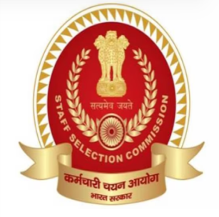
 |  |  | - SSC CHSL (Combined Higher Secondary Level)
 |  |  | - SSC MTS (Multi-Tasking Staff) & Havaldar (CBIC & CBN)
 |  |  | - SSC GD Constable (General Duty)
 |  |  | - SSC JE (Junior Engineer)
 |  |  | - SSC JHT (Junior Hindi Translator / Senior Hindi Translator)
 |  |  | - SSC Stenographer Grade ‘C’ & ‘D’
 |  |  | - SSC Selection Post (Phase I, II, III, etc.)
 |  |  | - SSC CPO
 |  |  | - SSC Delhi Police Constable
 |  |  | - SSC Delhi Police MTS / Head Constable / Ministerial Exams
 |  |  | - SSC Scientific Assistant (IMD)
 |  |  | - SSC Constable (Driver) in Delhi Police
 |  |  | - SSC Constable (Tradesman)
 |  |  | - SSC Central Region / Northern Region / etc
 | BANKING | Institute of Banking Personnel Selection  (IBPS) | - IBPS RRB PO | https://www.ibps.in ​ | 
 |  |  | - IBPS RRB SO
 |  |  | - IBPS RRB Clerk
 |  |  | - IBPS PO
 |  |  | - IBPS SO IT Officer
 |  |  | - IBPS Clerk
 |  |  | - IBPS RRB GBO (Scale-II)
 |  |  | - IBPS SO
 |  | State Bank of India  (SBI) | - SBI Clerk | https://sbi.co.in/web/careers | 
 |  |  | - SBI SO
 |  |  | - SBI PO
 |  |  | - SBI CBO (Circle Based Officer)
 |  | Securities and Exchange Board of India (SEBI) | SEBI Grade A Officer (Assistant Manager) | https://www.sebi.gov.in | 
 |  | Export Credit Guarantee Corporation of India Ltd (ECGC) | ECGC PO | https://www.ecgc.in | 
 |  | Reserve Bank of India | - RBI Grade B Officers | https://www.rbi.org.in | 
 |  |  | - RBI Assistant
 |  | National Bank for Agriculture and Rural Development (NABARD) | - NABARD Grade A (Assistant Manager) | https://www.nabard.org | 
 |  |  | - NABARD Grade B (Assistant Manager)
 |  | Bank of Baroda | - Probationary Officers (PO) | https://www.bankofbaroda.in/careers | 
 |  |  | - Specialist Officers (SO
 |  |  | - Local Bank Officers (LBO)
 |  |  | - Office Assistants (Peon)
 |  | Indian Bank | - Specialist Officer (SO) | https://www.indianbank.in/careers | 
 |  |  | - Local Bank Officer (LBO)
 |  |  | - Local Bank Officer (LBO)
 |  | Indian Overseas Bank | - IOB Local Bank Officer (LBO) | https://www.iob.in/careers | 
 |  |  | - Indian Overseas Bank Apprentice
 |  | Union Bank of India | - Union Bank Apprentice exam |  | 
 |  |  | - Union Bank SO
 |  | Central Bank of India | Credit Officer (PGDBF) | https://www.centralbankofindia.co.in | 
 |  | Bihar State Co-operative Bank (BSCB) | - Clerk | https://www.biharscb.co.in | 
 |  |  | - Assistant
 |  |  | - Manager
 |  | Rajasthan State Cooperative Bank (RSCB) | - Senior Manager | https://rajcrb.rajasthan.gov.in | 
 |  |  | - Computer Programmer
 |  |  | - Banking Assistant
 |  | Himachal Pradesh State Cooperative Bank | - Assistant Manager | https://www.hpscb.com | 
 |  |  | - Junior Clerk
 | TEACHING | KENDRIYA VIDYALAYA SANGATHAN | - Assistant Commissioner | https://kvsangathan.nic.in | 
 |  |  | - KVS PGT (Post Graduate Teacher)
 |  |  | - KVS TGT (Trained Graduate Teacher)
 |  |  | - KVS PRT (Primary Teacher)
 |  |  | - KVS Principal
 |  |  | - KVS Vice-Principal
 |  |  | - KVS Librarian,
 |  | NAVODAYA VIDYALAYA  SAMITI | - Assistant Commissioner | https://navodaya.gov.in | 
 |  |  | - Principal
 |  |  | - Vice-Principal
 |  |  | - PGT (Post Graduate Teacher)
 |  |  | - TGT (Trained Graduate Teacher
 |  | BPSC TRE | - PGT | https://bpsc.bihar.gov.in/ | 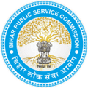
 |  |  | - TGT
 |  |  | - PRT
 |  | UTTAR PRADESH SECONDARY EDUCATION SERVICES SELECTION BOARD | - UPTET | https://updeled.gov.in | 
 |  |  | - UPTGT
 |  |  | - SUPER TET
 |  |  | - UP PGT
 |  |  | - UP LT
 |  |  | - UP GIC Lecturer
 |  | Madhya Pradesh Professional Examination Board | MP TET | https://mpbse.nic.in | 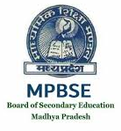
 |  | Punjab State Council of Educational Research and Training | PSTET | https://pstet.pseb.ac.in | 
 |  | Himachal Pradesh Board of School Education | HP TET | https://hpbose.org | 
 |  | Uttarakhand Board of School Education | UTET | https://ubse.uk.gov.in | 
 |  | Board of School Educ8ation, Haryana | HTET | https://bseh.org.in | 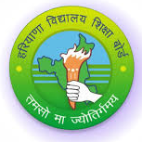
 |  | Jammu Kashmir Public Service Commission | - JKSSB | https://jkssb.nic.in | 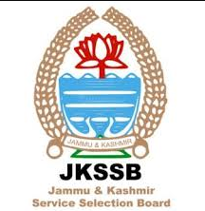
 |  |  | - JKPSC
 |  |  | - JKTET
 |  | Rajasthan Public Service Commission | - REET Grade I | https://rajeduboard.rajasthan.gov.in | 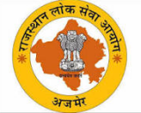
 |  |  | - REET Grade II
 |  | Gujarat State Education Board | - Gujarat TET | https://gsebservice.gujarat.gov.in | 
 |  |  | - Gujarat GSET
 |  |  | - Gujarat TAT
 |  | Maharashtra State Council of Examination | MAHATET | https://mahatef.in | 
 |  | Jharkhand Staff Selection Commission | - JSSC | https://jssc.nic.in | 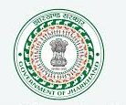
 |  |  | - JTET
 |  | Chhattisgarh Professional Examination Board | CG TET | https://cgtet.co.in | 
 |  | West Bengal Board of Primary Education | WBTET | https://wbbpe.org | 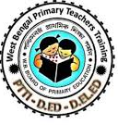
 |  | West Bengal School Service Commission | WBSSC SLST |  | 
 |  | Directorate of Secondary Education, Assam | Assam Teacher Eligibility Test | https://scert.assam.gov.in | 
 |  | Arunachal Pradesh Public Service Commission | - Arunachal Pradesh TET/ PGT | https://apsc.gov.in | 
 |  |  | - Arunachal Pradesh TET / TGT
 |  | Meghalaya Education Department | Meghalaya TET | https://megeducation.gov.in | 
 |  | State Council of Educational Research and Training, Nagaland | Nagaland Teacher Eligibility Test | https://npsc.co.in | 
 |  | Department of Education, Manipur | - Manipur TET (MTET) | https://manipur.gov.in | 
 |  |  | - Contract Lecturers/GTs
 |  |  | - Primary Teachers (PTs)
 |  | Teacher's Recruitment Board Tripura | Tripura-TET | https://trb.tripura.gov.in | 
 |  | Mizoram Board of School Education | Mizoram TET | https://mzu.edu.in | 
 |  | Board of Secondary Education (BSE), Odisha | - OTET (Odisha Teacher Eligibility Test) | https://bseodisha.ac.in | 
 |  |  | - OSSTET (Odisha Secondary School Teacher Eligibility Test)
 |  | Department of School Education, Government of Andhra Pradesh | Andhra Pradesh TET | https://apteachers.in | 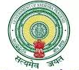
 |  | School Education Department, Government of Telangana | Telangana TET | https://tstet.aptonline.in | 
 |  | Teachers Recruitment Board, Tamil Nadu government | - TNTET (Tamil Nadu Teacher Eligibility Test) | https://trb.tn.gov.in | 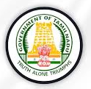
 |  |  | - PG TRB (Post Graduate Teacher Recruitment)
 |  |  | - UG TRB (Graduate Teacher Recruitment)
 |  | Kerala Pareeksha Bhavan | - KTET Category 1 (Classes 1-5) | https://ktet.kerala.gov.in | 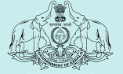
 |  |  | - KTET Category 2 (Classes 6-8)
 |  |  | - KTET Category 3 (Classes 9-10)
 |  |  | - KTET Category 4 (Language Teachers, Special Teachers and Physical Education Teachers)
 |  | Department of School Education & Literacy, Karnataka | - KPSC Teacher Recruitment Exam | https://kpsc.kar.nic.in | 
 |  |  | - KARTET | https://schooleducation.kar.nic.in
 |  | Goa Board of Secondary and Higher Secondary Education | Goa TET | https://goa.gov.in | 
 |  | Delhi Subordinate Services Selection Board | - PRT (Primary) | https://dsssb.delhi.gov.in/ | 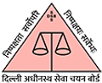
 |  |  | - TGT (Trained Graduate)
 |  |  | - PGT (Post Graduate).
 |  | Samagra Shiksha Abhiyan (SSA), Chandigarh | - JBT (Junior Basic Teacher/Primary Teacher) | https://ssachd.nic.in/ | 
 |  |  | - TGT (Trained Graduate Teacher)
 |  |  | - PGT (Post Graduate Teacher)
 |  | Railway Recruitment Board | RRB Railway Teacher Recruitment | https://indianrailways.gov.in | 
 |  | Andaman and Nicobar Administration | Andaman and Nicobar TGT | https://dge.gov.in | 
 | INDIAN RAILWAYS | RRB  (Railway Recruitment Board) | - RRB NTPC | https://rrbapply.gov.in | 
 |  |  | - Railway Foundation Courses
 |  |  | - RRB Section Controller
 |  |  | - Railways Group D
 |  |  | - RRB ALP
 |  |  | - RRB Technician Grade 3
 |  |  | - RRB Nursing Superintendent
 |  |  | - RRB Jr. Engineer
 |  |  | - RPF Sub Inspector |  | 
 |  |  | - RPF Constable
 | UNIVERSITY GRANTS COMMISSION NATIONAL ELIGIBILITY TEST | National Testing Agency | - Assistant Professor | https://ugcnet.nta.ac.in | 
 |  |  | - JRF ( Junior Research Fellowship)
 |  |  | - PHD
 | NURSING | RRB  (Railway Recruitment Board) | - Nursing Superintendent | https://indianrailways.gov.in/rrb | 
 |  |  | - Staff Nurse
 |  |  | - Pharmacist
 |  | AIIMS Common Recruitment Examination (CRE) | - Medical Superintendent | https://aiimsexams.ac.in | 
 |  |  | - NORCET (Nursing Officers)
 |  |  | - CRE-4 (Senior Nursing Officer)
 |  | Uttarakhand Medical Service Selection Board | - Nursing Officer | https://ukmssb.org | 
 |  |  | - GNM & ANM
 |  |  | 3. Pharmacist
 |  | Health & Medical Education Department, Jammu & Kashmir | - Staff Nurse | https://hme.jk.gov.in | 
 |  |  | - Female Multipurpose Health Worker (FMPHW) | https://dhsjammu.jk.gov.in
 |  |  | - Nursing Aid
 |  |  | - Pharmacist
 |  | Delhi Subordinate Services Selection Board | DSSSB Nursing Officer | https://dsssb.delhi.gov.in | 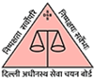
 |  | Delhi Health & Family Welfare Department | Delhi NHM Staff Nurse |  | 
 |  | Rajasthan Staff Selection Board | - Staff Nurse | https://rsmssb.rajasthan.gov.in | 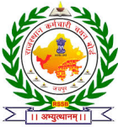
 |  |  | - Community Health Officer
 |  |  | - Nursing Tutors
 |  | Haryana Staff Selection Commission | - Community Health Officer | https://hssc.gov.in | 
 |  |  | - Staff Nurse
 |  | Himachal Pradesh Rajya Chayan Aayog | - Staff Nurses | https://hpsc.hp.gov.in | 
 |  |  | - Nursing Officer
 |  | Chandigarh Administration | - Staff Nurse | https://chandigarh.gov.in | 
 |  |  | - Sister Grade II
 |  |  | - PGIMER Chandigarh
 |  | Punjab Health & Family Welfare Department | - Staff Nurse | https://health.punjab.gov.in | 
 |  |  | - PPSC Medical Officer | https://ppsc.gov.in
 |  | Uttar Pradesh Government | - Community Health Officer | https://upnrhm.gov.in | 
 |  |  | - Staff Nurse | https://dgme.up.gov.in
 |  |  | - ANM | https://dgme.up.gov.in
 |  |  | - KGMU/SGPGI for Nursing Officer | https://kgmu.org / https://sgpgims.org.in
 |  |  | - Directorate General of Medical Education & Training | https://dgme.up.gov.in
 |  | Bihar Technical Service Commission | - Staff Nurse/Nursing Office | https://btsc.bihar.gov.in | 
 |  |  | - ANM
 |  | West Bengal Health Recruitment Board | Staff Nurse Grade II | https://hfw.wbhealth.gov.in | 
 |  | Sikkim Public Service Commission | - Staff Nurse | https://spsc.sikkim.gov.in | 
 |  |  | - Sister Grade-II
 |  |  | - Nursing Officer
 |  | Directorate of Medical Education, Assam | - Staff Nurse | https://dme.assam.gov.in | 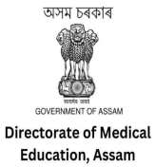
 |  |  | - Community Health Officer
 |  |  | - Grade-III (Non-Technical)
 |  | Meghalaya Medical Services Recruitment Board | - staff Nurse | https://meghealth.gov.in | 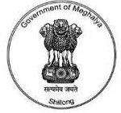
 |  |  | - ANM
 |  | Directorate of Health Services, Arunachal Pradesh | - Staff Nurse | https://health.arunachal.gov.in | 
 |  |  | - Nursing Tutors/Lecturers
 |  | Department of Health & Family Welfare, Nagaland | - Staff Nurse (Class-III) | https://health.nagaland.gov.in | 
 |  |  | - Medical Officer
 |  | Directorate of Health Services , Manipur | - Staff Nurse | https://dhsmanipur.nic.in | 
 |  |  | - ANM
 |  |  | - Nursing Sister, Tutor, etc
 |  | Mizoram Public Service Commission | - Staff Nurse | https://mpsc.mizoram.gov.in | 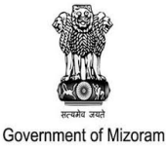
 |  |  | - ANM
 |  | Health & Family Welfare Department, Tripura | - Staff Nurses | https://health.tripura.gov.in | 
 |  |  | - ANMs
 |  |  | - GNM
 |  | Jharkhand Staff Selection Commission | Staff Nurse | https://jssc.nic.in | 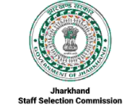
 |  | Chhattisgarh Vyapam | CG Staff Nurse Exam | https://vyapam.nic.in | 
 |  | Odisha Subordinate Staff Selection Commission | Nursing Officer Exam | https://osssc.gov.in
 |  | Directorate of Health Services, Maharashtra | - Staff Nurse/Nursing Officer | https://arogya.maharashtra.gov.in | 
 |  |  | - Community Health Officer
 |  | Madhya Pradesh Employees Selection Board (Vyapam) | Staff Nursing | https://esb.mp.gov.in | 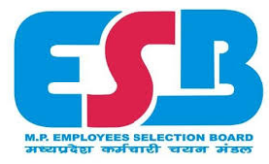
 |  | Gujarat Public Service Commission, & Arogyasathi | - Nursing Superintendent, Tutor | https://gpsc.gujarat.gov.in | 
 |  |  | - Staff Nurses
 |  |  | - Community Health Officer
 |  | Telangana Medical Health and Services Recruitment Board | Staff Nurses | https://mhsrb.telangana.gov.in | 
 |  | Health, Medical & Family Welfare Department, AP | - Staff Nurse | https://health.ap.gov.in | 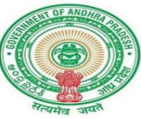
 |  |  | - ANM
 |  | Medical Services Recruitment Board, Tamil Nadu | - Staff Nurses | https://mrb.tn.gov.in | 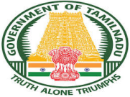
 |  |  | - ANM
 |  | Kerala Public Service Commission | - Staff Nurse Grade-II | https://kerala.psc.gov.in | 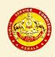
 |  |  | - Nursing Officer
 |  | Karnataka Public Service Commission | - Staff Nurse | https://kpsc.karnataka.gov.in | 
 |  |  | - Community Health Officers
 |  | Directorate of Health Services, Goa | - Staff Nurse | https://dhsgoa.gov.in | 
 |  |  | - Matron
 |  |  | - Walk-in Interviews for specific posts
 |  | Directorate of Health Services Andaman | - Staff Nurses | https://db.and.nic.in | 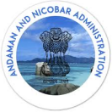
 |  |  | - ANMs
 | CIVIL SERVICES | Union Public Service Commission | - Civil Service examination | https://upsc.gov.in | 
 |  |  | - Indian Economic Service
 | Engineering Recruitment | IITs | GATE (Graduate Aptitude Test in Engineering) | https://gate2026.iitr.ac.in
 |  | Union Public Service Commission | ESE (Engineering Services Examination) | https://upsc.gov.in | 
 |  | SSC | Staff Selection Commission Junior Engineer | https://ssc.gov.in | 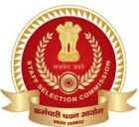
 |  | RRB | Railway Recruitment Board Junior Engineer | https://indianrailways.gov.in/rrb | 
 |  | ISRO | - Scientist/Engineer  - Technical Assistant | https://www.isro.gov.in | 
 | Defence Exams | Union Public Service Commission | CAPF – Central Armed Police Force | https://upsc.gov.in | 
 |  | Union Public Service Commission | CDS – Combined Defense Services |  | 
 |  | Union Public Service Commission | NDA – National Defence Academy/ Naval Academy |  | 
 |  | Indian Air Force (IAF) | - AFCAT – Air Force Common Admission Test | https://afcat.cdac.in | 
 |  |  | - Indian Air Force Airmen | https://indianairforce.nic.in
 |  |  | - Indian Air Force Group C
 |  | Indian Coast Guard | - Indian Coast Guard Assistant commandant |  | 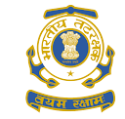
 |  |  | - Indian Coast Guard Navik
 |  | Indian Navy | - INET (Indian Navy Entrance Test) | https://inet.navy.gov.in | 
 |  |  | - Navy's 10+2 B.Tech | https://joinindiannavy.gov.in
 |  |  | - Technical Entry Schemes (SSC Tech)
 |  | Indian Army | - Judge Advocate General | https://joinindianarmy.nic.in | 
 |  |  | - Technical Entry Schemes (TGC)
 |  |  | - Technical Entry Schemes (SSC Tech)
 |  |  | - Indian Army Junior Commissioned Office
 |  |  | - Indian Army Teacher | https://awesindia.com
 |  |  | - Army ordinance corps | https://joinindianarmy.nic.in
 |  |  | - Indian Army NCC | https://indianarmy.nic.in
 |  |  | - Territorial Army | https://territorialarmy.in
 |  | Sashastra Seema Bal | SSB Constable | https://ssb.gov.in | 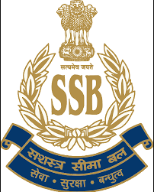
 | Judiciary Exams | Delhi | Delhi Judiciary (DJS) | https://delhihighcourt.nic.in | 
 |  | Haryana Judiciary | Haryana Public Service Commission (HPSC) | https://hpsc.gov.in | 
 |  | Punjab Judiciary (PCS-J) | Punjab Public Service Commission (PPSC) | https://highcourtchd.gov.in | 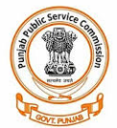
 |  | UP Judiciary (UP PCS J) | Uttar Pradesh Public Service Commission (UPPSC) | https://uppsc.up.nic.in | 
 |  | Uttarakhand Judiciary (UKPSC-J) | Uttarakhand Public Service Commission (UKPSC) | https://ukpsc.gov.in | 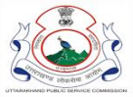
 |  | Himachal Pradesh Judiciary | Himachal Pradesh Public Service Commission (HPPSC) | https://hphighcourt.nic.in | 
 |  | JKPSC Civil Judge | Jammu & Kashmir High Court | https://jkhighcourt.nic.in | 
 |  | Madhya Pradesh | MP Judiciary | https://mphc.gov.in | 
 |  | Chhattisgarh Judiciary | Chhattisgarh Public Service Commission (CGPSC) | https://highcourt.cg.gov.in | 
 |  | Rajasthan | Rajasthan Judiciary | https://hcraj.nic.in | 
 |  | Gujarat Judiciary | Gujarat High Court | https://gujarathighcourt.nic.in | 
 |  | Maharashtra Judiciary (MPSC-J) | Maharashtra Public Service Commission (MPSC) | https://mpsc.gov.in | 
 |  | Bihar | Bihar Judiciary (BPSC Judicial Service) | https://bpsc.bihar.gov.in | 
 |  | Jharkhand Judiciary Exam (JPSC-J) | Jharkhand Public Service Commission (JPSC) | https://jpsc.gov.in | 
 |  | West Bengal Judiciary | West Bengal Public Service Commission (WBPSC) | https://wbpsc.gov.in | 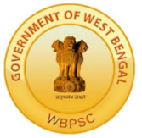
 |  | Odisha Judicial Services Exam | Odisha Public Service Commission (OPSC) | https://opsc.gov.in | 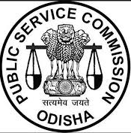
 |  | Tamil Nadu | TNPSC Civil judge Exam (TNPSC-J) | https://tnpsc.gov.in | 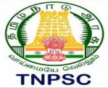
 |  | Karnataka Judiciary | Karnataka High Court | https://karnatakajudiciary.kar.nic.in | 
 |  | Andhra Pradesh Judiciary (APJS) | Andhra Pradesh High Court | https://aphc.gov.in | 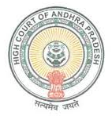
 |  | Telangana Judiciary Exams (TSJS) | Telangana High Court | https://tshc.gov.in | 
 |  | Assam | Assam Judicial Services Exams (AJS) | https://ghconline.gov.in | 
 |  | Tripura Judiciary (TJS) | Tripura High Court | https://hc.tripura.gov.in | 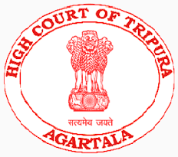
 |  | Meghalaya Higher Judicial Services Exams (MJS) | Meghalaya High Court | https://meghalayahighcourt.nic.in | 
 |  | Manipur Judicial Service Exams (MPSC-J) | Manipur High Court | https://hcmimipur.gov.in | 
 |  | Nagaland Judicial Services Exams (NJS) | Nagaland High Court | https://nagalandhighcourt.nic.in | 
 |  | Mizoram Judicial Service Exams (MZJS) | Mizoram High Court | https://mizoramhighcourt.nic.in | 
 |  | Sikkim Judicial Services Exams (SJS) | Sikkim High Court | https://highcourtofsikkim.nic.in | 
 | INSURANCE EXAMS | Life Insurance Corporation Limited (LIC) | - LIC ADO | https://licindia.in | 
 |  |  | - LIC AAO
 |  |  | - LIC HFL | https://lichousing.com
 |  | New India Assurance Co. Limited (NIACL) | - Administrative Officer | https://www.niacl.com | 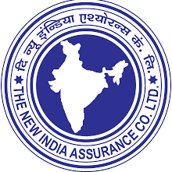
 |  |  | - Assistant
 |  | National Insurance Company Limited (NICL) | Administrative Officer | https://nationalinsurance.nic.co.in | 
 |  | Oriental Insurance Company Limited (OICL) | Administrative Officer | https://orientalinsurance.org.in | 
 |  | United India Insurance Company (UIIC) | Administrative Officer | https://uiic.co.in | 
 |  | Insurance Regulatory and Development Authority (IRDA) | - Assistant Manager | https://irdai.gov.in | 
 |  |  | - Assistant
 |  | ESIC | - 1. Clerical:  - UDC (Upper Division Clerk),  - Stenographer. | https://esic.gov.in | 
2. Technical & Medical
- Junior Engineer (JE),
- Nursing Officer/Staff Nurse, Doctors
 |  | General Insurance Corporation of India | - GIC Assistant Manager  - SO officer | https://gicofindia.com | 
 |  | United India Insurance Company Limited | Administrative Officer (AO) | https://uiic.co.in | 
12 | Other Government Exams | RBI | - Grade B Officers | https://opportunities.rbi.org.in | 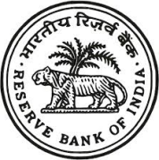
 |  |  | - RBI Assistant
 |  | Intelligence Bureau | - Assistant Central Intelligence Officer | https://mha.gov.in | 
 |  |  | - Security Assistant
 |  |  | - MTS
 |  | Food Corporation Of India | - Manager | https://fci.gov.in | 
 |  |  | - Assistant Grade lII
 |  |  | - Junior Engineer (JE)
 |  |  | - Stenographer Grade-II
 |  |  | - Typist
 |  |  | - Watchman
 |  | Navodaya Vidyalaya  Samiti | - Jr. Secretariat Assistant (HQ/RO Cadre) | https://navodaya.gov.in | 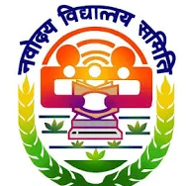
 |  |  | - Jr. Secretariat Assistant
 |  |  | - Lab Attendant
 |  |  | - Multi-Tasking Staff
 |  | Kendriya Vidyalaya  Sangathan | - Assistant Section Officer (ASO) | https://kvsangathan.nic.in | 
 |  |  | - Administrative Officer
 |  |  | - Finance Officer
 |  |  | - Assistant Engineer
 |  |  | - Secretariat Assistant (Sr. & Jr)
 |  |  | - Stenographer
13 |  | India Post | - MTS | https://indiapost.gov.in | 
 |  |  | - Assistant Branch Postmaster (ABPM) | https://indiapostgdsonline.cept.gov.in
 |  |  | - Dak Sevak
 |  |  | - Branch Postmaster (BPM)
14 |  | Bhabha Atomic Research Centre (BARC) | - Scientific Officer | https://www.barconline.cept.gov.in | 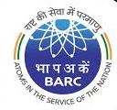
 |  |  | - Administration | https://www.barc.gov.in/careers
 |  |  | - Accountant,
 |  |  | - Security
 |  |  | - Assistants
15 |  | ICAR IARI | Assistant | https://iari.res.in | 
16 |  | National Informatics Centre (NIC) | - Scientist. | https://www.nic.in/careers | 
 |  |  | - Engineer
 |  |  | - Technical Assistant
17 | Accounting & Commerce | Institute of Chartered Accountants of India | Chartered Accountancy (CA) | https://www.icai.org | 
 |  |  | Association of Chartered Certified Accountants | https://www.accaglobal.com | 
 |  | Institute Of Company Secretaries Of India | Company Secretary | https://www.icsi.edu | 
 |  | The Chartered Financial Analyst | Chartered Financial Analyst | https://www.cfainstitute.org | 
 |  | American Institute of Certified Public Accountants (AICPA) | Certified Public Accountant (CPA) | https://www.aicpa.org | 
18 | POLICE EXAMS | Staff Selection Commission (ssc) | - Delhi Police Constable | https://ssc.gov.in | 
 |  |  | - Delhi Police Head Constable
 |  |  | Delhi Police Driver
 |  |  | - Delhi Police MTS
 |  | Uttar Pradesh Police | - UPSI | https://uppbpb.gov.in | 
 |  |  | - UP Police Constable
 |  |  | - UP Police ASI
 |  | Bihar Police | - Sub-Inspector (SI). | https://csbc.bih.nic.in | 
 |  |  | - Constable
 |  | West Bengal Police | - Constable | https://wbpolice.gov.in | 
 |  |  | - Sub-Inspector (SI)
 |  |  | - other posts technical post
 |  | Assam Police | - Constable | https://slprbassam.in | 
 |  |  | - Sub-Inspector (SI)
 |  | Sikkim Police | - Constable | https://sikkimpolice.nic.in | 
 |  |  | - Sub-Inspector (SI)
 |  | Meghalaya Police | - Constable | https://megpolice.gov.in | 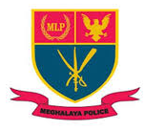
 |  |  | - Sub-Inspector
 |  |  | - MPRO Operator
 |  |  | - Driver Posts
 |  | Arunachal Pradesh Police | - Constables | https://arunpol.nic.in | 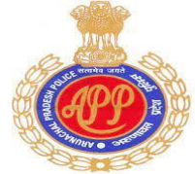
 |  |  | - MTS
 |  |  | - Sub-Inspector
 |  | Nagaland Police | - Constable | https://police.nagaland.gov.in | 
 |  |  | - Sub-Inspector
 |  | Manipur Police | - Constable | https://police.manipur.gov.in | 
 |  |  | - Specialized Constable
 |  |  | - Sub-Inspector
 |  | Tripura Police | - Sub-Inspector | https://police.tripura.gov.in | 
 |  |  | - Constable
 |  | Mizoram Police | - Sub-Inspector | https://police.mizoram.gov.in | 
 |  |  | - Constable
 |  | Jammu & Kashmir Police | - Sub-Inspector | https://jkpolice.gov.in | 
 |  |  | - constables
 |  | Punjab Police | - Sub-Inspector | https://punjabpolice.gov.in | 
 |  |  | - constables
 |  | Haryana Police | - Sub-Inspector | https://haryanapolice.gov.in | 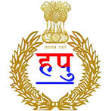
 |  |  | - constables
 |  | Himachal Pradesh Police | - Sub-Inspector | https://himpol.nic.in | 
 |  |  | - constables
 |  | Rajasthan Police | - Sub-Inspector | https://police.rajasthan.gov.in | 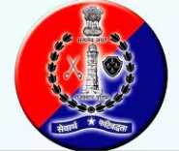
 |  |  | - constables
 |  | Madhya Pradesh Police | - Sub-Inspector | https://esb.mp.gov.in | 
 |  |  | - constables
 |  | Jharkhand Police | - Sub-Inspector | https://jssc.nic.in | 
 |  |  | - constables
 |  | Chhattisgarh Police | - Sub-Inspector | https://cgpolice.gov.in | 
 |  |  | - constables
 |  | Maharashtra Police | - Sub-Inspector | https://mahapolice.gov.in | 
 |  |  | - constables
 |  | Andhra Pradesh Police | - Sub-Inspector | https://slprb.ap.gov.in | 
 |  |  | - constables
 |  | Telangana Police | - Sub-Inspector | https://tslprb.in | 
 |  |  | - constables
 |  | Karnataka Police | - Sub-Inspector | https://ksp-recruitment.in | 
 |  |  | - constables
 |  | Tamil Nadu Police | - Sub-Inspector | https://esptn.gov.in | 
 |  |  | - constables
 |  | Kerala Police | - Sub-Inspector | https://keralapolice.gov.in | 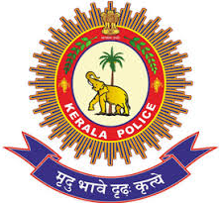
 |  |  | - constables
 |  | Goa Police | - Sub-Inspector | https://goapolice.gov.in | 
 |  |  | - constables
 | Andhra Pradesh | APPSC | - Group 1 | https://psc.ap.gov.in | 
 |  | APPSC | - Group 2
 |  | APPSC | - Group 3
 |  | APPSC | - Group 4
 |  | AP Police | - Police SI | https://slprb.ap.gov.in
 |  | DSC | - DSC SGT | https://apdsc.apcfss.in
 |  | DSC | - DSC PGT
 |  | DSC | - DSC TGT
 | Arunachal Pradesh | APPSC | 1 .ACS | https://appsc.gov.in | 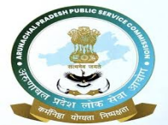
 |  | APPSC | 2.APS
 | Assam | APSC | - CCE DCS | https://apsc.nic.in | 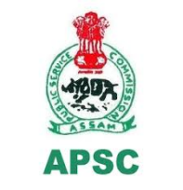
 |  | APSC | - CCE ACS
 | Bihar | BPSC | - CCE | https://bpsc.bihar.gov.in | 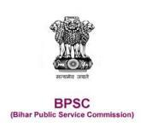
 |  | Bihar Police | - SI |  | 
 | Chhattisgarh | CGPSC | SSE | https://psc.cg.gov.in | 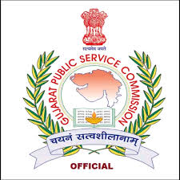
 | Goa | GPSC | GCS | https://gpsc.goa.gov.in | 
 | Gujarat | GPSC | - Class 1 | https://gpsc.gujarat.gov.in | 
 | Gujarat | GJ Police | - PSI | https://ojas.gujarat.gov.in | 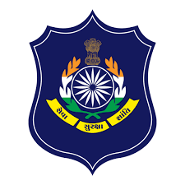
 | Haryana | HPSC | HCS | https://hpsc.gov.in | 
 | Himachal Pradesh | HPPSC | HPAS | https://hppsc.hp.gov.in | 
 | Jharkhand | JPSC | JAS | https://jpsc.gov.in | 
 | Karnataka | KPSC | KAS | https://kpsc.kar.nic.in | 
 | Kerala | Kerala PSC | LDC | https://keralapsc.gov.in | 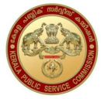
 | Madhya Pradesh | MPPSC | SSE | https://mppsc.mp.gov.in | 
 | Maharashtra | MPSC | MPSCS | https://mpsc.gov.in | 
 | Manipur | MPSC | MCS | https://mpscmanipur.gov.in | 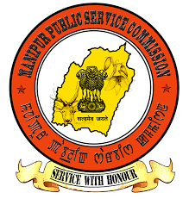
 | Meghalaya | MPSC | MCS | https://mpsc.nic.in | 
 | Mizoram | Mizoram PSC | MCS | https://mpsc.mizoram.gov.in | 
 | Nagaland | NPSC | NCS | https://npsc.nagaland.gov.in | 
 | Odisha | OPSC | OAS | https://opsc.gov.in | 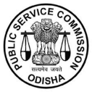
 | Punjab | PPSC | PCS | https://ppsc.gov.in | 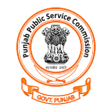
 | Rajasthan | RPSC | RAS | https://rpsc.rajasthan.gov.in | 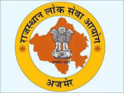
 | Sikkim | SPSC | SCS | https://spsc.sikkim.gov.in | 
 | Tamil Nadu | TNPSC | Group 1 | https://tnpsc.gov.in | 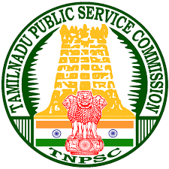
 | Telangana | TSPSC | Group 1 | https://tspsc.gov.in | 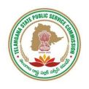
 | Tripura | TPSC | TCS | https://tpsc.tripura.gov.in | 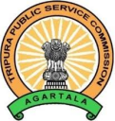
 | Uttar Pradesh | UPPSC | - PCS | https://uppsc.up.nic.in | 
 |  | UPSSSC | - PET | https://upsssc.gov.in | 
 |  | UPPRPB | - UP Police SI | https://uppbpb.gov.in | 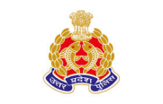
 | Uttarakhand | UKPSC | PCS | https://ukpsc.gov.in | 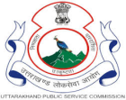
 | West Bengal | WBPSC | WBCS | https://wbpsc.gov.in | 
19 | PUBLIC SECTOR UNDERTAKING  MAHARATNA | Oil and Natural Gas Corporation (ONGC) | ONGC Recruitment | https://ongcindia.com/web/eng/career | 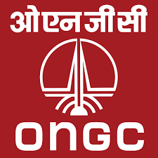
 |  | Bharat Heavy Electricals Limited (BHEL) | BHEL Recruitment | https://careers.bhel.in | 
 |  | Bharat Petroleum Corporation Limited (BPCL) | BPCL Recruitment | https://www.bharatpetroleum.in/Careers.aspx | 
 |  | Coal India Limited (CIL) | CIL Recruitment | https://www.coalindia.in/career | 
 |  | Gas Authority of India Limited (GAIL) | GAIL Recruitment | https://www.gailonline.com/Careers.html | 
 |  | Hindustan Petroleum Corporation Limited (HPCL) | HPCL Recruitment | https://www.hindustanpetroleum.com/hpcareers | 
 |  | Indian Oil Corporation Limited (IOCL) | IOCL Recruitment | https://www.iocl.com/PeopleCareers/job.aspx | 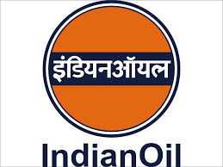
 |  | National Thermal Power Corporation (NTPC) | NTPC Recruitment | https://careers.ntpc.co.in | 
 |  | Power Grid Corporation of India (PGCIL) | PGCIL Recruitment | https://www.powergrid.in/career | 
 |  | Power Finance Corporation Limited (PFCL) | PFCL Recruitment | https://www.pfcindia.com/Career | 
 |  | Rural Electrification Corporation Limited (REC) | REC Recruitment | https://www.recindia.nic.in/careers | 
 |  | Steel Authority of India Limited (SAIL) | SAIL Recruitment | https://www.sail.co.in/en/careers | 
 |  | Oil India Limited (OIL) | OIL Recruitment | https://www.oil-india.com/oilrecruit1.html | 
 |  | Hindustan Aeronautics Limited (HAL ) | HAL Recruitment | https://hal-india.co.in/Careers | 
20 | PUBLIC SECTOR UNDERTAKING  NAVRATNA | Bharat Electronics Limited (BEL) | BEL Recruitment | https://bel-india.in/Careers | 
 |  | Container Corporation of India (CONCOR) | CONCOR Recruitment | https://concorindia.co.in/careers | 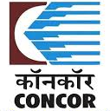
 |  | Engineers India Limited (EIL) | EIL Recruitment | https://engineersindia.com/career | 
 |  | National Aluminium Company (NALCO) | NALCO Recruitment | https://nalcoindia.co.in/careers | 
 |  | NBCC (India) Limited | NBCC Recruitment | https://nbccindia.in/careers | 
 |  | National Mineral Development Corporation (NMDC) | NMDC Recruitment | https://www.nmdc.co.in/careers | 
 |  | NLC India Limited (Neyveli Lignite) | NLC Recruitment | https://www.nlcindia.in/careers | 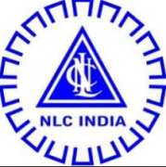
 |  | Rashtriya Ispat Nigam Limited (RINL) | RINL Recruitment | https://www.rinl.in/Careers | 
 |  | Shipping Corporation of India (SCI) | SCI Recruitment | https://shipindia.com/careers | 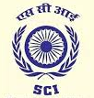
 |  | Rail Vikas Nigam Limited (RVNL) | RVNL Recruitment | https://www.rvnl.org/Career | 
 |  | Rashtriya Chemicals & Fertilizers Limited (RCF) | RCF Recruitment | https://www.rcfltd.com/careers | 
 |  | IRCON International | IRCON Recruitment | https://www.ircon.org/vacancy | 
 |  | RITES Limited | RITES Recruitment | https://www.rites.com/Careers | 
 |  | National Fertilizers Limited (NFL) | NFL Recruitment | https://nationalfertilizers.com/careers | 
 |  | Housing And Urban Development Corporation Limited (HUDCO) | HUDCO Recruitment | https://www.hudco.org/careers | 
 |  | Indian Renewable Energy Development Agency (IREDA) | IREDA Recruitment | https://www.ireda.in/careers | 
 |  | Central Warehousing Corporation (CWC) | CWC Recruitment | https://cwcindia.com/careers | 
 |  | Mazagon Dockyard Limited | Mazagon Dockyard Recruitment | https://mazagondock.in/careers | 
 |  | RailTel Corporation of India Limited (RCIL) | RCIL Recruitment | https://www.railtelindia.com/careers | 
 |  | SJVN Limited | SJVN Recruitment | https://www.sjvn.nic.in/careers | 
 |  | NHPC Limited | NHPC Recruitment | https://www.nhpcindia.com/careers | 
 |  | Solar Energy Corporation of India (SECI) | SECI Recruitment | https://www.seci.co.in/careers | 
 |  | Indian Railway Catering and Tourism Corporation (IRCTC) | IRCTC Recruitment | https://www.irctc.co.in/career.html | 
 |  | Indian Railway Finance Corporation (IRFC) | IRFCRecruitment | https://www.irfc.co.in/careers | 
 |  | Numaligarh Refinery (NRL) | NRL Recruitment | https://www.nrl.co.in | 
21 | Metro Rail | PMRC | Patna Metro Recruitment | https://patnmetrorail.com/career | 
 |  | MPMRCL | Indore Metro Recruitment | https://mpmetrorail.com/career | 
 |  | UPMRCL | - Agra Metro Recruitment | https://upmrc.com/career | 
 |  |  | - Kanpur Metro Recruitment | https://kanpurmetro.com/career
 |  |  | - Lucknow Metro Recruitment | https://lkmmrc.com/career
 |  |  | - Noida Metro Recruitment | https://nmrcnoida.com/career
 |  | Maha-Metro & Pune IT City Metro Rail Ltd. | Pune Metro Recruitment | https://mahametro.org/career | 
 |  | CIDCO | Navi Mumbai Metro Recruitment | https://cidco.maharashtra.gov.in/career | 
 |  | Maha-Metro | Nagpur Metro Recruitment | https://mahametro.org/career | 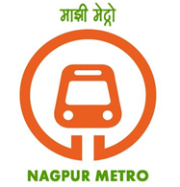
 |  | MMRC | Mumbai Metro Recruitment | https://recruitment.mmrcl.com | 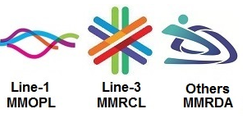
 |  | GMRC | Ahmedabad Metro Recruitment | https://gujaratmetrorail.com/career | 
 |  | SURMRCL | Surat Metro Recruitment | https://suratmetrorail.com/career
 |  | HMRL | Hyderabad Metro Recruitment | https://ltmetro.com/career | 
 |  | KMRL | Kochi Metro Recruitment | https://kochimetro.org/career | 
 |  | JMRC | Jaipur Metro Recruitment | https://transport.rajasthan.gov.in/jmrc/career | 
 |  | CMRL | Chennai Metro Recruitment | https://chennaimetrorail.org/career | 
 |  | Metro Railway & KMRC | Kolkata Metro Recruitment | https://mtp.indianrailways.gov.in/recruitment | 
 |  | BMRCL | Namma Metro (Bengaluru) Recruitment | https://bmrc.co.in/careers | 
 |  | DMRC | Delhi Metro Recruitment | https://delhimetrorail.com/career | 
 |  | GRMFL | Gurgaon Rapid Metro, | https://rapidmetroindia.com/career

